**WINDOWS SERVER 2012 CLUSTERING STEP-BY-STEP**

[December 31, 2012](https://clusteringformeremortals.com/2012/12/31/windows-server-2012-clustering-step-by-step/)[daveberm](https://clusteringformeremortals.com/author/daveberm/)

This article is the first in a series of articles on Clustering Windows Server 2012. This first article covers the basics first steps of any cluster, regardless of whether you are clustering Hyper-V, SQL Server Failover Clusters, File Servers, iSCSI Target Server or others. Future articles will cover more detailed instructions for each cluster resource type, but the following information is applicable to ALL clusters.

I’m assuming you know a little bit about clusters and why you would want to build one, so I won’t go into those details in this particular post. I also assume you are familiar with Windows Server 2012 and basic things like DNS, AD, etc. It is also worth noting that in Windows Server 2012 failover clustering comes with every edition, unlike Windows Server 2008 R2 and earlier where failover clustering was only included in Enterprise Edition and above.

This particular series will focus on a basic 2-node cluster, where we have two servers (named PRIMARY and SECONDARY) running Windows Server 2012 in a Windows Server 2012 Domain (domain controller named DC). It also assumes that PRIMARY and SECONDARY can communicate with each other over two network connections I have labeled PUBLIC and PRIVATE. In production scenarios these network connections should run through entirely different network gear (switches, routers, etc) to eliminate any single point of failure.

This series will be written in a very basic, step-by-step style that walks you through the process in an ordered list with basic instructions and plenty of screen shots to help illustrate the procedure where needed. So let’s begin at the beginning…

1. Add the Failover Clustering Feature on all of the servers you want to add to the cluster
   1. Open the Server Manager Dashboard (this 1st step will need to be completed on both PRIMARY and SECONDARY)
   2. Click on Add roles and features
   3. 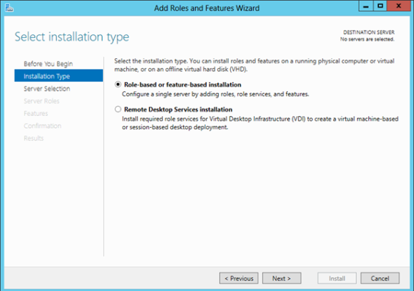

Choose Role-based or feature-based installation

* 1. 

Choose the server on which you wish to enable the failover cluster feature   
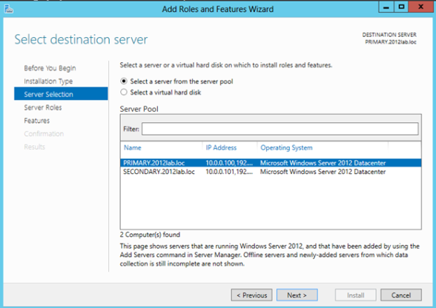

* 1. Skip over the Server Roles page  
     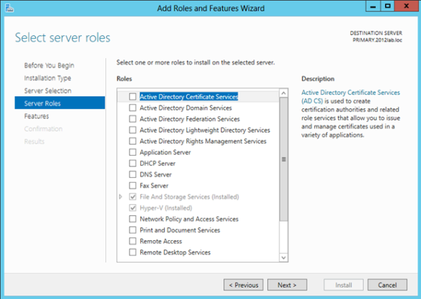
  2. On the Features page select Failover Clustering and click Next and then confirm the installation   
     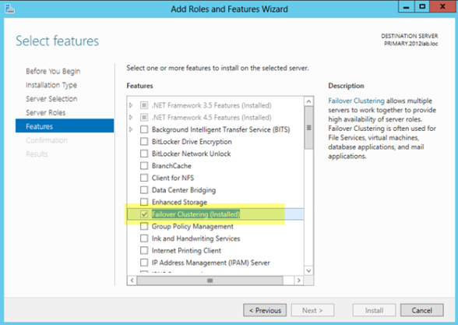

1. Before we start configuring the cluster, we need to consider what kind of storage the cluster will use. Traditionally clusters will use some sort of SAN, but with Windows 2012 not all clusters will use a SAN. For instance, if you are building a cluster to support SQL Server AlwaysOn Availability Groups your storage will be replicated by SQL Server, eliminating the need for a SAN. Also, with SMB 3.0 being support as cluster storage for [Hyper-V](http://technet.microsoft.com/en-us/library/jj614620.aspx) and [SQL Server](http://msdn.microsoft.com/en-us/library/hh759341.aspx) you may not have a traditional SAN for storage. And let’s not forget [clustered Storage Spaces](http://blogs.msdn.com/b/clustering/archive/2012/06/02/10314262.aspx) with shared SAS drives is also a possibility in Windows Server 2012. In addition to the options mentioned above, you also can use local disks and 3rd party host based replication solutions like [DataKeeper Cluster Edition](http://us.sios.com/products/steeleye-datakeeper-windows/) which is an excellent alternative which [I blog about](https://clusteringformeremortals.com/category/datakeeper/) pretty frequently.

For the purposes of this post, I am going to assume you have no shared storage. However, if you do have shared storage at this point you should configure you storage such that you have LUN(s) carved out and shared with each of the cluster nodes with one LUN being used as a disk witness and the remaining LUNs can be used for the application which you want to cluster. In lieu of a disk witness for our quorum, I am going to use a node and file share witness quorum type which I will explain later.

1. Now that Failover Clustering is enabled on each server, you can open the Failover Cluster Manager on your PRIMARY server. The first thing we will want to do is to run “Validate Configuration” so we can identify any potential issues before we begin. Click on Validate Cluster

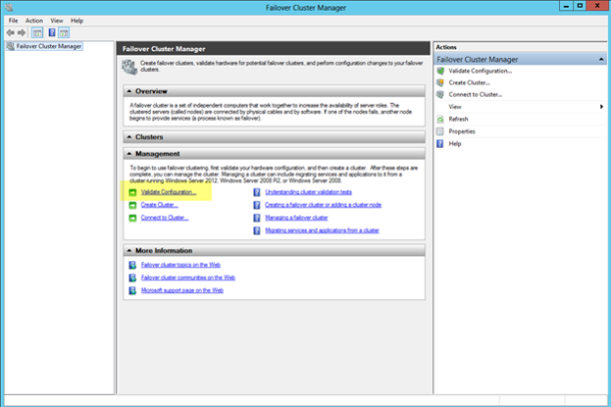

1. Step through the Validate a Configuration Wizard as shown in the following steps.
   1. Select the servers you want to cluster  
      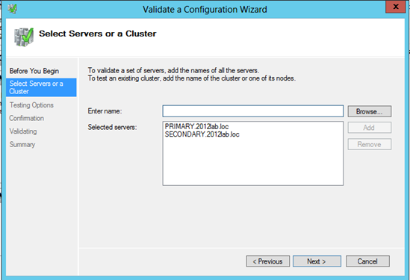
   2. Run all tests (depending on what roles you have installed on the servers you may get more or less tests. For instance, if Hyper-V is enabled there are new Hyper-V specific tests for clusters)  
      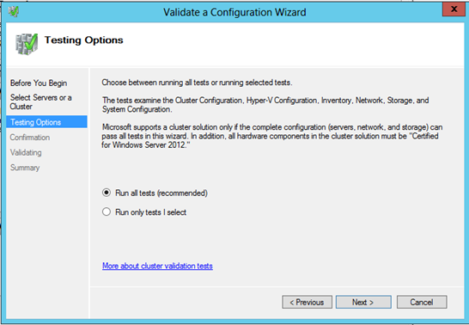
   3. Assuming you cluster “passed” validation you should have a report that looks similar to mine. You will notice that my report contains “warnings” but no errors. It is important for you to view the report and understand what warnings might be present, but you as long as you understand the warnings and they make sense for your particular environment you can move on. If you validation “failed”, you MUST fix the failures before moving on. Click View Report to view the report  
      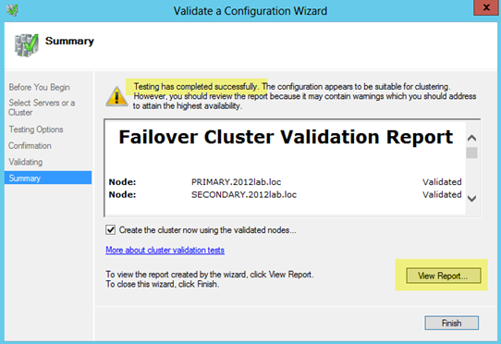
   4. You will see all of my warnings are related to storage, so I am not concerned since I have not configured any shared storage, so I would expect some of these thests to produce warnings.  
      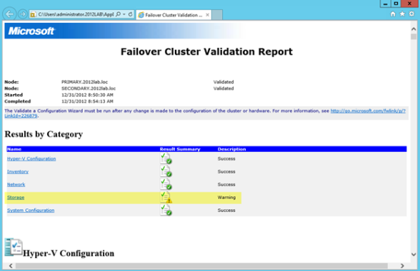

1. Once Validation completes without any errors, you will automatically be thrown into the Create Cluster Wizard. Walk through this wizard as shown below to create your basic cluster.
   1. In this first screen you will choose a name for your cluster and pick an IP address that will be associated with this name in DNS. This name is just the name used to manage your cluster – this is NOT the name that your clients will use to connect to the clustered resource(s) you will eventually create. Once you create this access point a new computer object will be created in AD with this name and a DNS A record will be created with this name and IP address.  
      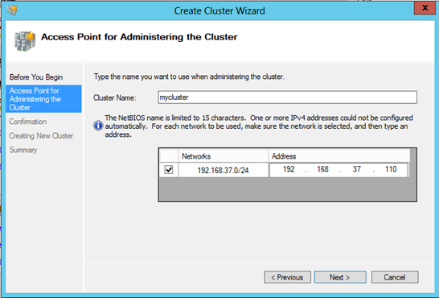
   2. On the confirmation screen you will see the name and IP address you selected. You will also see an option which is new with Windows Server 2012 failover clustering…”Add all eligible storage to the cluster”. Personally I’m not sure why this is selected by default, as this option can really confuse things. By default, this selection will add all shared storage (if you have it configured) to the cluster, but I have also seen it add just local, non-shared disks, to the cluster as well. I suppose they want to make it easy to support symmetric storage, but generally any host based or array based replication solutions are going to have some pretty specific instructions on how to add symmetric storage to the cluster and generally this option to add all disks to the cluster is more of a hindrance than a help when it comes to asymmetric storage. For our case, since I have no shared storage configured and I don’t want the cluster adding any local disks to the cluster for me automatically I have unchecked the Add all eligible storage to the cluster option.

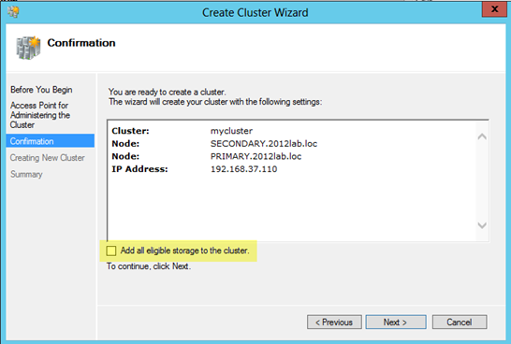

* 1. After you click next you will see that the cluster has finished the creation process, but there may be some warnings. In our case the warnings are probably related to the quorum configuration which we will take care of in the next step. Click View Report to check out any warnings.  
     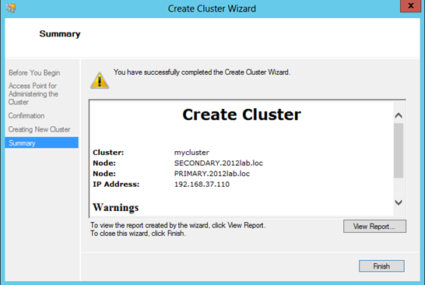  
     You see that the warning is telling use to change the quorum type.  
     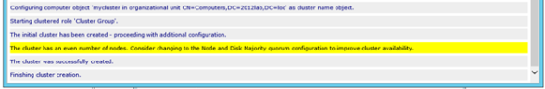

1. Because we have no shared storage, we will not be using a Node and Disk Majority quorum as suggested. Instead, we will use and Node and File Share Majority quorum. The following steps will help us configure the Node and File Majority Quorum
   1. A File Share Witness needs to be configured on a server that is not part of the cluster. A file share witness is a basic file share that the cluster computer name (MYCLUSTER in our case) has read/write access. The first step involves creating this file share. In our example, we are going to create a file share on our DC and give MYCLUSTER read/write access to it.
   2. The file share does not need to reside on a Windows 2012 server, but it does need to be on a Windows Server in the same domain as the cluster. The important thing to remember is that the cluster computer name that we created needs read/write access at both the share level and NTFS level. The following are some screen shots that walk you through this process on the DC server which is running Windows Server 2012 in my lab.  
      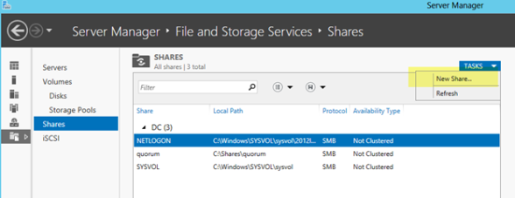

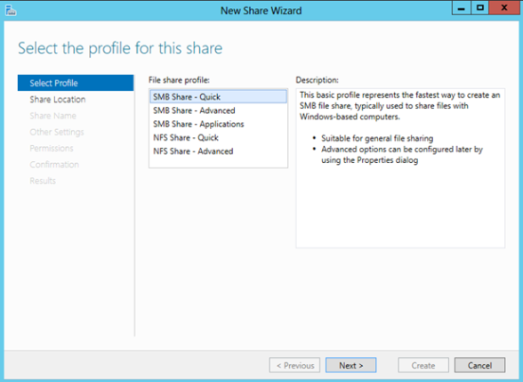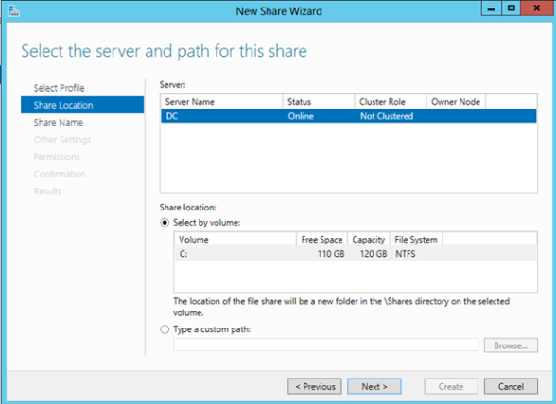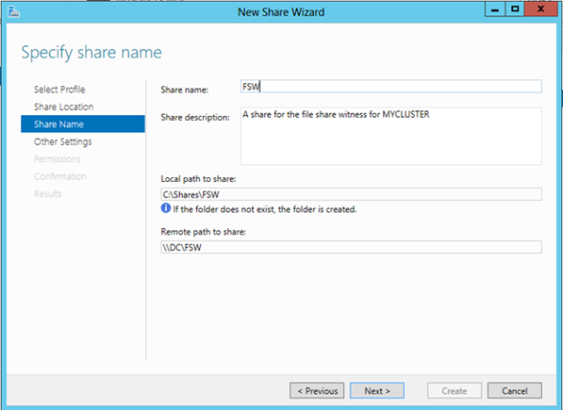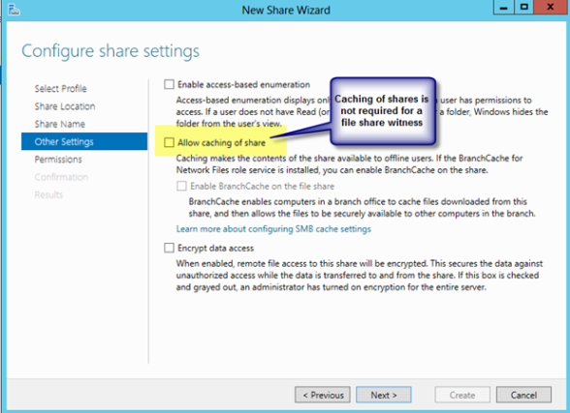  
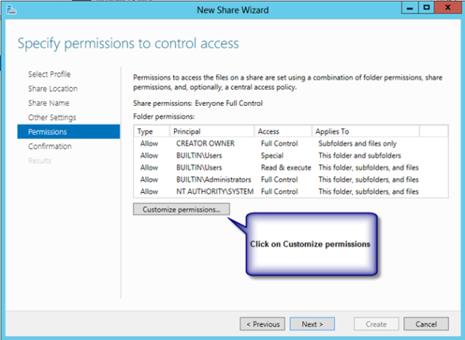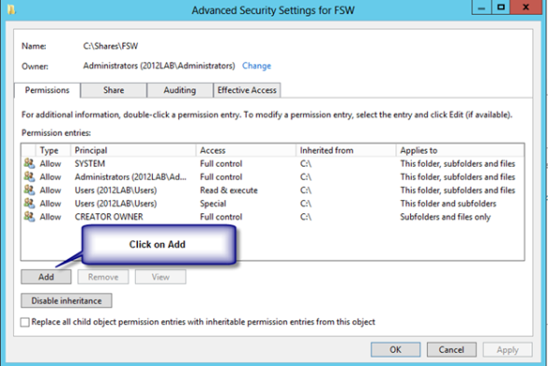  
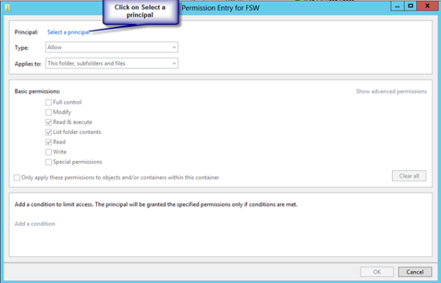

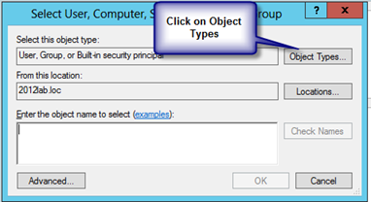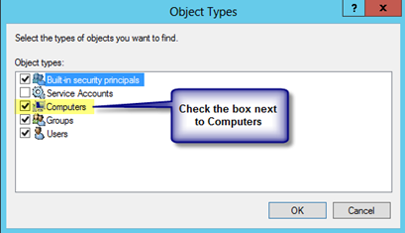

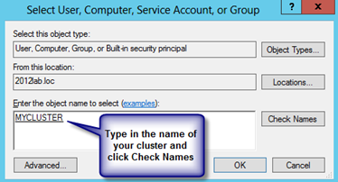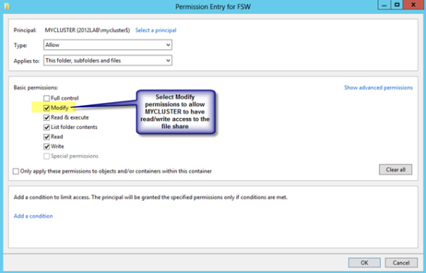  
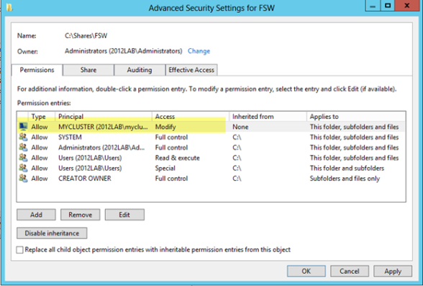

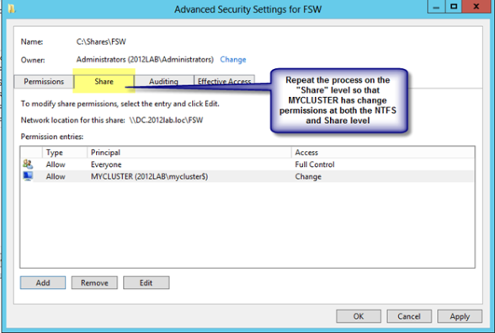

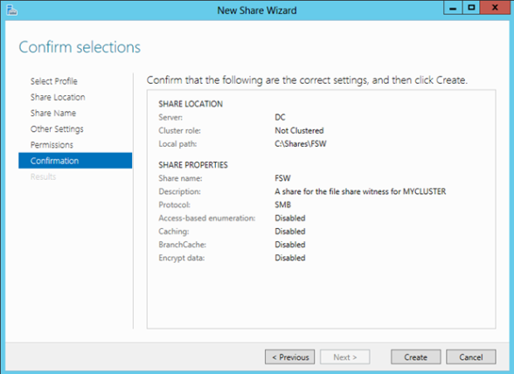

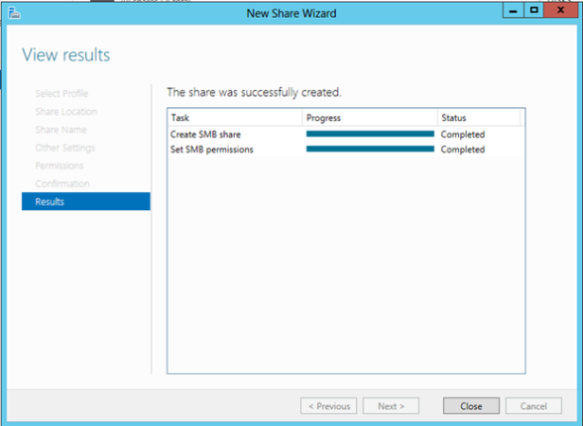

* 1. Now that we have the file share created on DC, we will go back to PRIMARY and use the Failover Cluster Manager to change the quorum type as shown in the following steps.  
     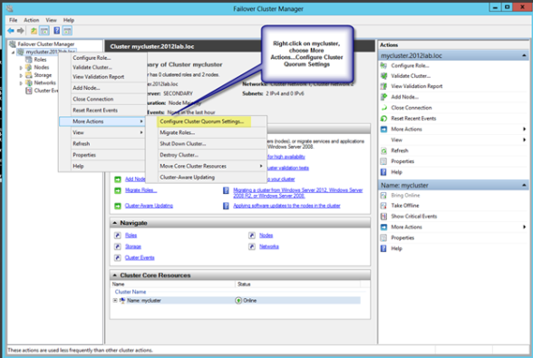  
     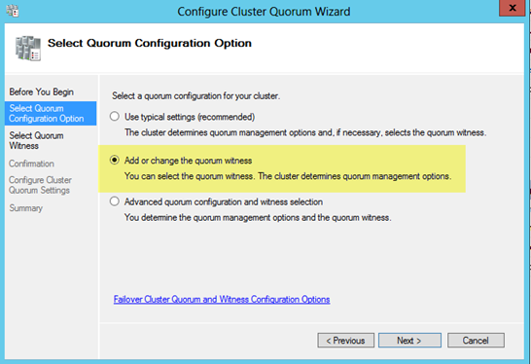  
     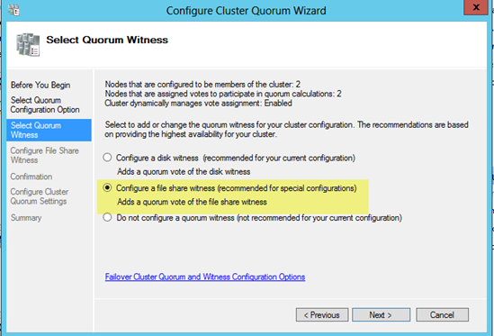  
     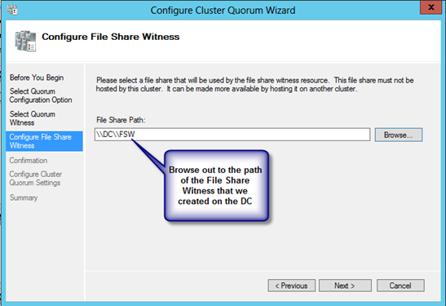  
     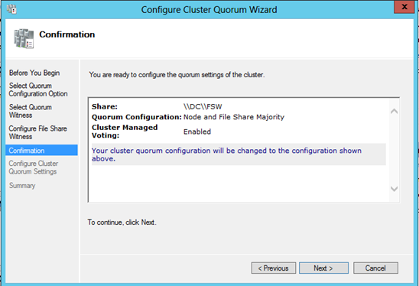  
     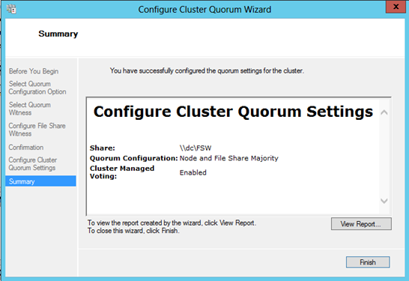  
     If by chance this wizard fails, it is most likely related to the permissions on the file share. Make sure you give the cluster computer name read/write permissions at BOTH the file share and security (NTFS) level and try again.

1. You now have a basic 2-node cluster and are ready to move on to the next step…creating your cluster resources. I will be publishing a series of articles on how to cluster different resources, starting with SQL 2012 in my next post.